Expense Tracker & Budget Optimizer
✅ Features:
- Set monthly budget
- Add expenses (category + amount)
- View all expenses
- Calculate total expenses
- Show remaining budget
- Category-wise spending summary
- Simple optimization advice
Program in c++ :
#include <iostream>
#include <vector>
#include <string>
#include <map>
Using namespace std;
// Structure to store expense details
Struct Expense {
String category;
Float amount;
};
// Function to calculate total expenses
Float calculateTotal(vector<Expense> &expenses) {
Float total = 0;
For (auto &e : expenses) {
Total += e.amount;
}
Return total;
}
// Function to display all expenses
Void viewExpenses(vector<Expense> &expenses) {
Cout << “\n--- All Expenses ---\n”;
If (expenses.empty()) {
Cout << “No expenses recorded.\n”;
Return;
}
For (int I = 0; I < expenses.size(); i++) {
Cout << I + 1 << “. “ << expenses[i].category
<< “ – Rs. “ << expenses[i].amount << endl;
}
}
// Function for category-wise summary
Void categorySummary(vector<Expense> &expenses) {
Map<string, float> summary;
For (auto &e : expenses) {
Summary[e.category] += e.amount;
}
Cout << “\n--- Category-wise Spending ---\n”;
For (auto &pair : summary) {
Cout << pair.first << “ : Rs. “ << pair.second << endl;
}
}
// Function to give optimization advice
Void optimizationAdvice(float budget, float total) {
Cout << “\n--- Budget Optimization Advice ---\n”;
If (total > budget) {
Cout << “⚠ You have exceeded your budget!\n”;
Cout << “Suggestion: Reduce spending on non-essential categories.\n”;
}
Else if (total > 0.75 * budget) {
Cout << “⚠ You are close to your budget limit.\n”;
Cout << “Suggestion: Monitor expenses carefully.\n”;
}
Else {
Cout << “✅ Your spending is under control.\n”;
Cout << “Good job maintaining your budget!\n”;
}
}
Int main() {
Vector<Expense> expenses;
Float budget = 0;
Int choice;
Do {
Cout << “\n====== Expense Tracker & Budget Optimizer ======\n”;
Cout << “1. Set Monthly Budget\n”;
Cout << “2. Add Expense\n”;
Cout << “3. View All Expenses\n”;
Cout << “4. Calculate Total Expenses\n”;
Cout << “5. Show Remaining Budget\n”;
Cout << “6. Category-wise Spending Summary\n”;
Cout << “7. Optimization Advice\n”;
Cout << “8. Exit\n”;
Cout << “Enter your choice: “;
Cin >> choice;
Switch (choice) {
Case 1:
Cout << “Enter your monthly budget: “;
Cin >> budget;
Break;
Case 2: {
Expense e;
Cout << “Enter category (Food/Travel/etc): “;
Cin >> e.category;
Cout << “Enter amount: “;
Cin >> e.amount;
Expenses.push_back€;
Cout << “Expense added successfully!\n”;
Break;
}
Case 3:
viewExpenses(expenses);
break;
case 4:
cout << “Total Expenses: Rs. “
<< calculateTotal(expenses) << endl;
Break;
Case 5:
Cout << “Remaining Budget: Rs. “
<< budget – calculateTotal(expenses) << endl;
Break;
Case 6:
categorySummary(expenses);
break;
case 7:
optimizationAdvice(budget, calculateTotal(expenses));
break;
case 8:
cout << “Exiting program…\n”;
break;
default:
cout << “Invalid choice!\n”;
}
} while (choice != 8);
Return 0;
}
Output of the program :
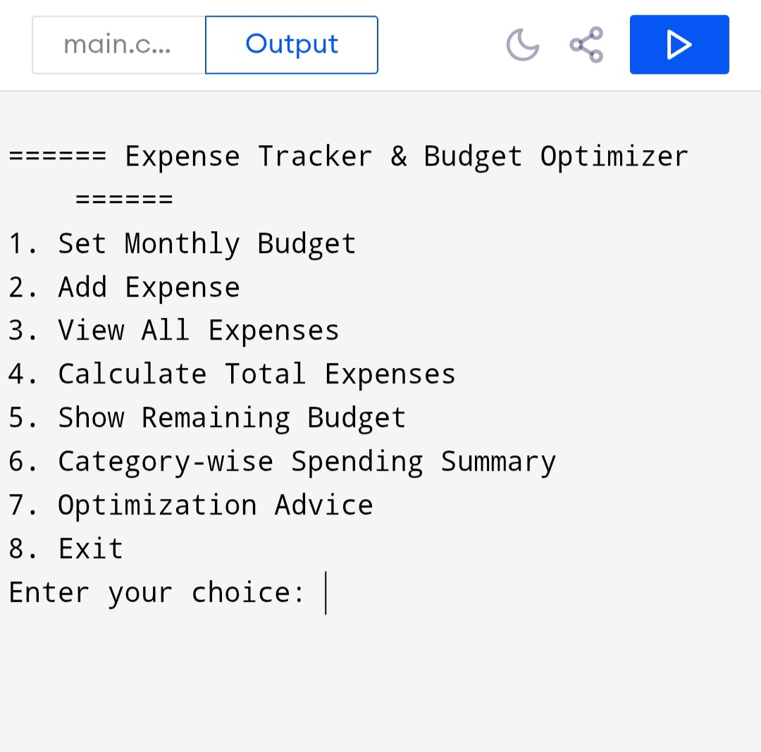

Step 1 :
====== Expense Tracker & Budget Optimizer ======
1. Set Monthly Budget
2. Add Expense
3. View All Expenses
4. Total Expenses
5. Remaining Budget
6. Category Summary
7. Optimization Advice
8. Exit
Enter choice: 1
Enter budget: 10000

Next step 2 :
Enter choice: 2
Enter category: Food
Enter amount: 2000
Expense added!

Next step 3 :
Enter choice: 2
Enter category: Travel
Enter amount: 1500
Expense added!

Next step 4 :
Enter choice: 3
--- All Expenses ---
1. Food – Rs. 2000
2. Travel – Rs. 1500
3. Shopping – Rs. 3000

Next step 5 :
Total expenses
Enter choice: 4
Total: Rs. 6500
Next step 6 :
Enter choice: 5
Remaining: Rs. 3500

Next step 6 :
Enter choice: 6
--- Category-wise Spending ---
Food : Rs. 2000
Shopping : Rs. 3000
Travel : Rs. 1500

Next step 7 :
Enter choice: 7

--- Budget Optimization Advice ---
⚠ You are close to your budget limit.

Finally exit :
Enter choice: 8
Exit…

